History Magazine

Inside the decadent love affair of Cleopatra and Mark Antony

A Roman general and an Egyptian queen, Mark Antony and Cleopatra flaunted their scandalous love affair while challenging the power of Rome.
This 1883 painting by Lawrence Alma-Tadema shows Mark Antony impatiently waiting for a glimpse of the alluring Cleopatra when they meet in Tarsus on her luxurious barge.
Photograph by CHRISTIE’S IMAGES/CORBIS/CORDON PRESS
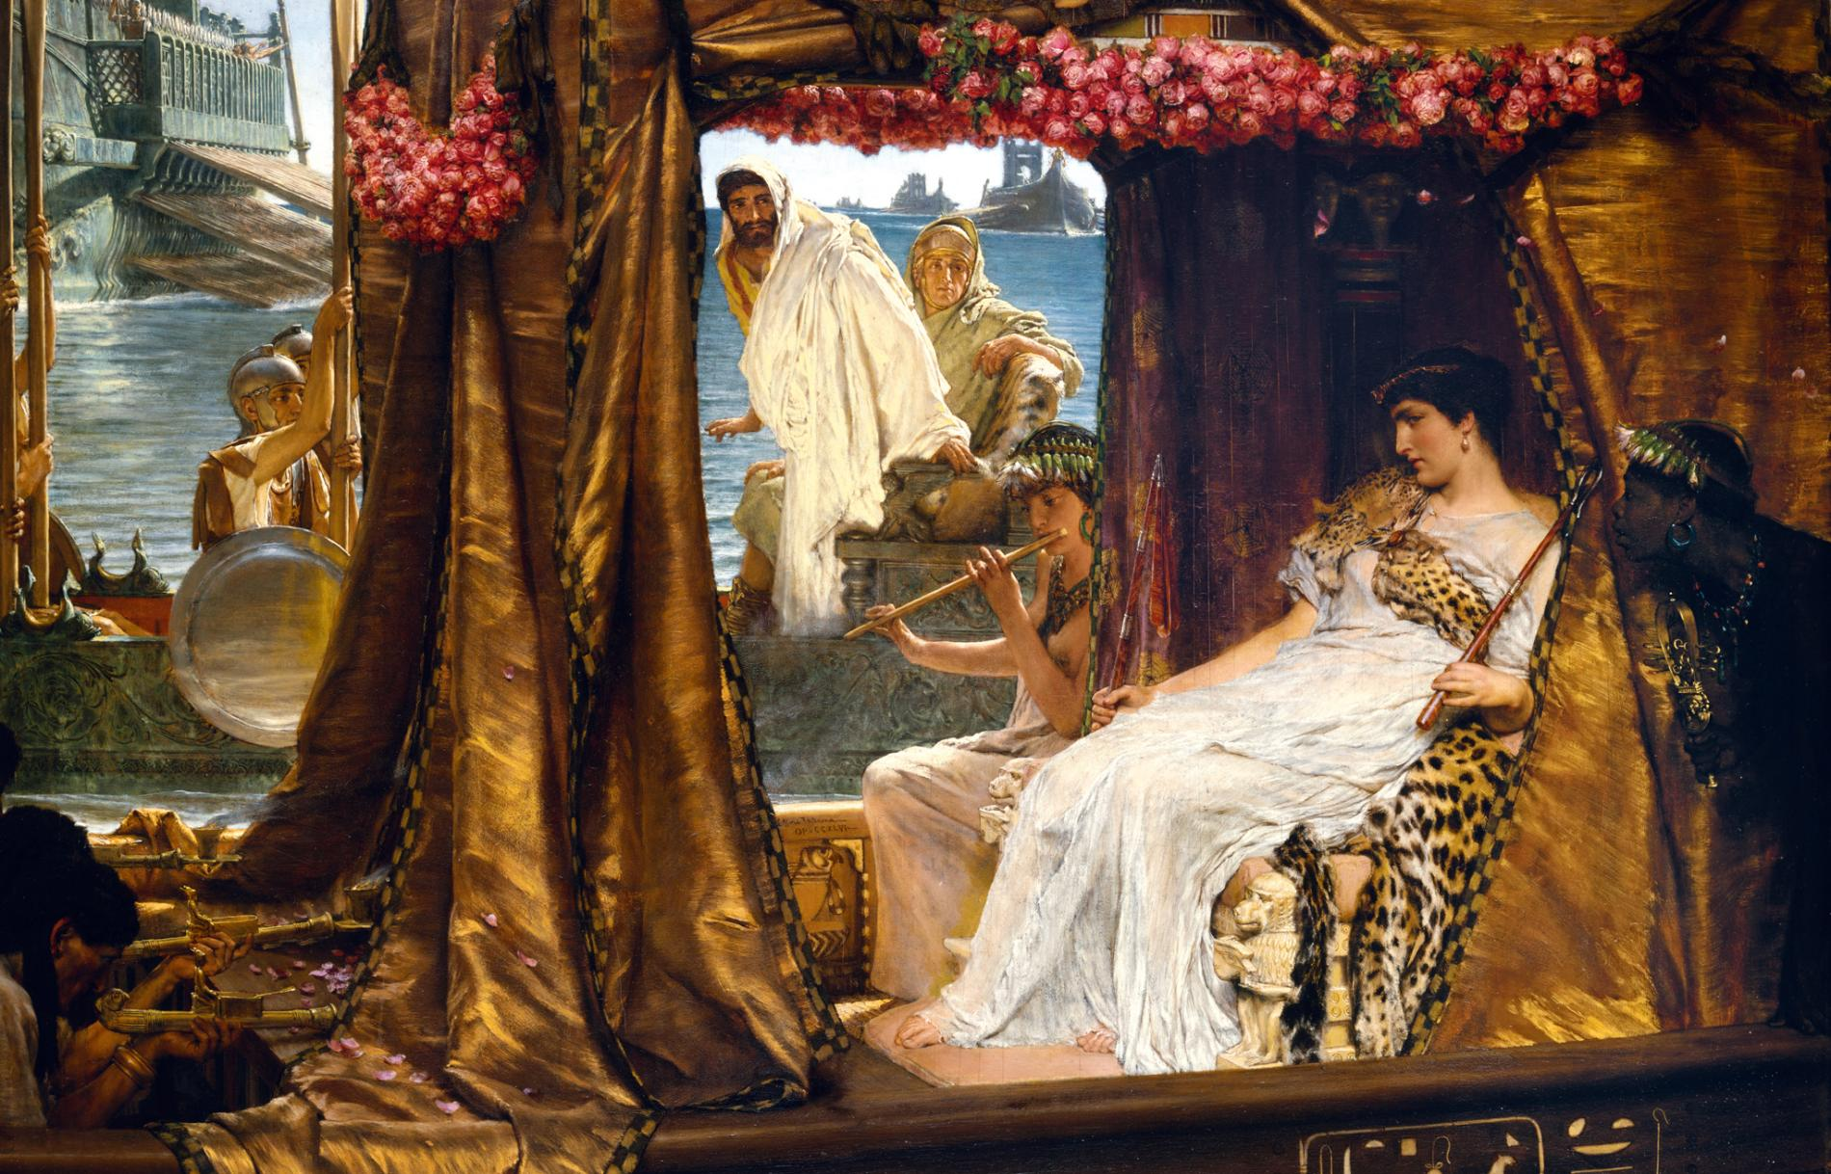

By Fernando Lillo Redonet

PUBLISHED February 13, 2019
In 42 B.C. Rome’s three most powerful men carved up the republic among them. The triumvirate of Lepidus, Octavian, and Mark Antony was an uneasy alliance after turbulent times. Placed in charge of the eastern provinces, Mark Antony found himself far from Rome and immersed in the Hellenistic culture he had always adored. It was a heady combination that drew him into the arms of Cleopatra, Egypt’s beguiling queen. (Read more about archaeologists' search for Cleopatra.)
As Antony journeyed to take up his new responsibilities, amorous adventures ranked low on his agenda. The triumvirate that ruled over Rome’s vast territories needed to urgently restructure the army in the east, secure new sources of military funding, and launch a punitive expedition against the Parthians to avenge a humiliating defeat in 53 B.C. Julius Caesar had been planning such an expedition before his assassination, and Antony was keen to be seen to continue his great mentor’s work. He also knew that a major victory against a foreign foe would greatly enhance his personal prestige and power.

Mark Antony’s interests, however, extended beyond Roman politics. He had a deep love of the Greek Hellenistic culture that Alexander the Great’s conquests had firmly embedded in the lands that now formed Rome’s eastern provinces. The abundant cultural distractions helped to alleviate the heavy cares of state, and Antony took full advantage as he toured his territories. Visiting Athens, he won the sobriquet “Dionysus the giver of joy,” and traveling in Asia Minor, he was met in Ephesus by a spectacular procession of men and women dressed as satyrs and priestesses of Bacchus, the Roman god of revelry. The citizens of Ephesus bestowed upon the Roman Antony the divine title of “Dionysus the benefactor.” (Learn more about Greek culture that Antony adored.)

Antony’s grand tour then took him to Tarsus, in modern-day southern Turkey. From here he dispatched a messenger to the Queen of Egypt, inviting her to a meeting in the city. This was politics, not pleasure, as Rome needed to tap into Egypt’s immense wealth, abundant grain supplies, and military strategic location. Cleopatra also had strong political reasons for meeting Antony. Winning the friendship of one of Rome’s most powerful men would bring closer links with the republic, consolidating her grip on the throne and perhaps even expanding her kingdom. Already playing a brilliant political game, Cleopatra delayed her departure, heightening Antony’s anticipation and ensuring the preparations were in place to make the Roman’s first encounter with Egypt’s queen one to remember. (Learn more about Egypt's female pharaohs and their power.)

The Queen of Egypt On the rear wall of the temple dedicated to the goddess Hathor, in Dendera, Cleopatra VII had herself depicted as a queen, alongside Caesarion, the son she had with Julius Caesar. Photograph by GEORGE STEINMETZ

A Sensational Entrance
Cleopatra dramatically played on Mark Antony’s fascination for Greek culture and his love of luxury. She approached Tarsus by sailing up the Cydnus River in a magnificent boat with a golden prow, purple sails, and silver oars. As musicians played, Cleopatra reclined under a gold-embroidered canopy dressed as Aphrodite, Greek goddess of love. She was fanned by youths dressed as Eros and waited upon by girls dressed as sea nymphs, while servants wafted perfume toward the gaping crowds lining the river. As sound and smell embellished this visually suggestive tableau, the impression made by Cleopatra must have been truly extraordinary.
Antony was overwhelmed by the spectacle. The Greek historian Plutarch describes a scene in which the Roman was abandoned in the city square as his attendants joined citizens racing to the river for a first glimpse of the queen. Caught off guard, Antony decided to invite Cleopatra to a banquet. However, the Egyptian queen was in complete control of events, and instead Antony found himself accepting her invitation to a feast she’d already prepared. According to Athenaeus, quoting Socrates of Rhodes, gold and precious gems dominated the decor of the dining hall, which was also hung with expensive carpets of purple and gold. Cleopatra provided expensive couches for Antony and his entourage, and to the triumvir’s amazement, the queen told him with a smile that they were a gift. Antony tried to reciprocate but soon realized he could not compete with Cleopatra.
Cleopatra's younger sister was captured by Julius Caesar in 47 B.C., and sent to live in Ephesus at the temple of Artemis. Six years later, following Cleopatra’s meeting with Mark Antony, the queen persuaded him to have her executed.
According to Plutarch, the queen had been convinced that her conquest of Antony would be easier than her earlier seduction of Julius Caesar—she was now far more experienced in the ways of the world. At 28 she had the confidence, intelligence, and beauty of a mature woman. She was sure of winning over Antony through a combined assault of conspicuous consumption and generosity, proving both Egypt’s abundant resources and her famed seductive charms. By some accounts Cleopatra’s beauty would not have turned heads at first sight, but she was deeply charismatic and was noted for her sweetness of voice. Cleopatra also knew she had the advantage: Antony had seen her in Alexandria 14 years earlier and been captivated by her then. Now they fell wildly in love.

Days of Wine and Roses
Antony and Cleopatra spent the winter of 41-40 B.C. in Alexandria, reveling in the unique mix of Egyptian and Greek culture for which the city was renowned. They were inseparable companions, playing dice, drinking, and hunting together. The lovers developed a taste for nocturnal escapades, walking the streets dressed as slaves. On one occasion Antony was even jostled and struck in an unsuspecting crowd. They organized lavish banquets for each other. Money was no object for what they called “The society of inimitable livers.” Writing about the reckless extravagance of these banquets, Plutarch described what his grandfather had seen when invited to visit the royal kitchens. The vast quantity of food being prepared, including eight entire roast boars, amazed him. This led him to speculate about the great numbers of guests expected, at which the royal cook burst out laughing. He said that in fact only 12 diners were coming, but they always prepared much more food, as Antony’s appetites were so unpredictable.

Cleopatra's Pearl
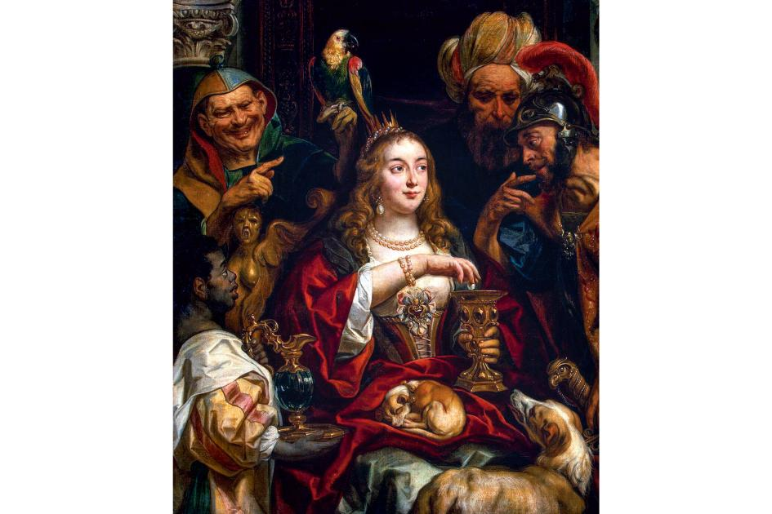
Oil painting by Jacob Jordaens, 1653
Photograph by FINE ART IMAGES/SCALA, FLORENCE
Pliny the Elder's account tells that Cleopatra boasted to Antony that she could spend ten million sesterces on one dinner. During dessert at the next banquet, Cleopatra called for a goblet of vinegar. She removed a valubale pearl earring and dropped it in. The priceless jewel dissolved, and then Cleopatra drank the mixture, thus consuming a huge fortune. This story is generally believed to be apocryphal, but some believe that some form of spectacle involving a pearl may have taken place.
Antony seemed to live a double life, and not just because he was already married with a highly political wife in Rome. There were two sides to his character: The sobriety and gravitas of the Romans and the fun-loving Dionysian spirit of the Greeks. Indeed, Alexandrians said that while he was in the company of Egyptians Antony wore the mask of comedy, but with the Romans he would switch to the mask of tragedy.

Love Children
Statue of the twin children of Antony and Cleopatra, born in late 40 B.C.
Photograph by KENNETH GARRETT/CORBIS/CORDON PRESS
One anecdote recounts Antony’s irritation when Cleopatra witnessed his poor performance at fishing. Having had no luck, Antony secretly ordered a diver to load his hook with fish that had already been caught. After he landed these in quick succession, Cleopatra realized what was going on; she loudly praised Antony’s skill and invited friends to return and admire his ability with rod and line the next day. Unbeknownst to Antony, the queen ordered a diver to put an obviously dead fish on Antony’s hook. Thinking that this time it was a genuine catch, Antony hauled it in to gales of laughter. “General, leave the fishing rod to us poor rulers of Pharos and Canopus,” Cleopatra teased him, “Your prey is cities, kingdoms, and continents.”

The Tragedy’s Final Scenes
Antony and Cleopatra had achieved a contented balance between their taste for pleasure and their political responsibilities. However, the spring of 40 B.C. brought news from Rome that shattered the hedonistic idyll of the lovers: Antony’s wife was causing trouble. Fulvia and Antony’s brother had mounted a political challenge to Octavian, who ruled the west from Rome. Naturally, Antony was implicated and it’s likely he had some knowledge and probably gave them his tacit approval. But the conspiracy collapsed, and Antony had to do everything possible to persuade Octavian of his innocence, including returning to Italy. Conveniently, though not suspiciously, Fulvia died that year, and Antony seized the political opportunity.
To prove his loyalty and cement the alliance, Antony married Octavian’s sister, Octavia. She was considered by some to be more beautiful than Cleopatra, but as a model of sober Roman virtue, she was very different from the pleasure-loving Egyptian.
Antony finally returned east in 37 B.C. and immediately resumed his passionate affair. He still saw in Cleopatra not only a matchless lover but also a highly efficient ruler, whose political ambitions were attuned with his own. He bolstered her right to rule Egypt, while she supported his belated campaign against the Parthians, a military venture that ended in disaster.

Mark Antony and Cleopatra’s dream of creating a great empire in the east was destroyed by Octavian’s decisive victory at the Battle of Actium in 31 B.C. A Roman coin commemorated the defeat of Egypt. Photograph by WERNER FORMAN/GTRES
In Rome, Octavian viewed these activities with growing disdain. Tensions grew between the former allies and then erupted into a war that Octavian presented as a struggle against a dissolute Egyptian queen into whose clutches Antony had fallen. The armies of the Roman rivals met in Greece, where Octavian managed to cut Antony’s supply lines to Egypt. Forced into action, Antony took Cleopatra’s advice to fight at sea. In 31 B.C. about 900 ships clashed at the Battle of Actium. It was a closely fought engagement. But when Cleopatra’s galleys fled Antony followed, and his forces soon surrendered. The lovers were defeated, and in a dramatic fashion, both took their own lives. Mark Antony’s death removed the last obstacle to Octavian becoming sole emperor of Rome. He assumed the title Augustus in 27 B.C.

Rise and Fall
44 B.C. Octavian and Mark Antony compete for power after Julius Caesar's death.
41 B.C. To tap Egypt’s resources for his military campaigns, Antony invites Cleopatra to Tarsus. The two become lovers and allies.
40 B.C. After Cleopatra gives birth to his twins, Antony returns to Rome and is forced into a political marriage with Octavian's sister.
37 B.C. Antony rejoins Cleopatra, who becomes pregnant with their third child.
32 B.C. Octavian strips Antony of his powers and declares war on Cleopatra.
31 B.C. Octavian defeats the combined forces of Antony and Cleopatra at the Battle of Actium.
30 B.C. Octavians invades Egypt and takes Alexandria. Antony commits suicide, and Cleopatra follows suit rather than face humiliation in Rome.
https://www.nationalgeographic.com/archaeology-and-history/magazine/2015/10-11/antony-and-cleopatra/

