563 Drama: Everyman 26/02/20
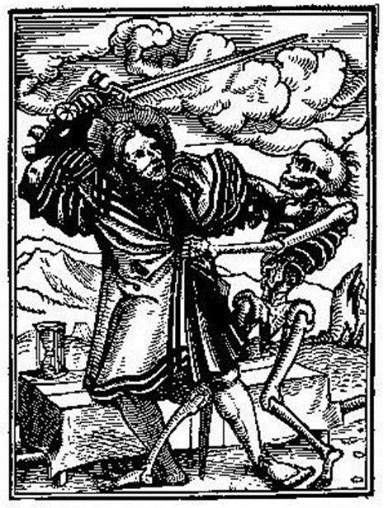
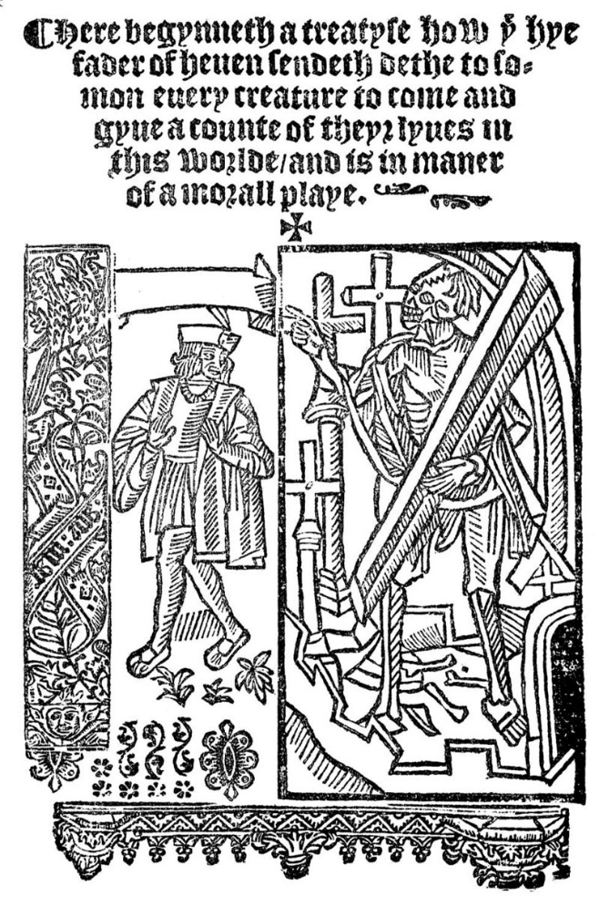

Frontispiece from edition of Everyman published by John Sklot c. 1530. Reads:
Here begins a treatise how the high Father of Heaven sends Death to summon every creature to come and give account of their lives in this world, and is in the manner of a moral play.
The Somonyng of Everyman (The Summoning of Everyman), usually referred to simply as Everyman, is a late 15th-century morality play. [It] … uses allegorical characters to examine the question of Christian salvation and what Man must do to attain it.

Web resources
Internet Medieval Sourcebook, edited by Paul Halsall, Fordham University Centre for Medieval Studies.
https://web.archive.org/web/20100110055355/http://www.fordham.edu/halsall/Sbook.html
Accessed 26/02/20 at 12h37
Voice of the Shuttle
http://vos.ucsb.edu/search-results.asp
Accessed 26/02/2020 at 12h41
Luminarium Anthology of English Literature
http://www.luminarium.org/medlit/everyman.htm

Allegory
Everyman is a dramatized allegory. An allegory is a narrative in which the characters and action, and sometimes the setting as well, have two levels of meaning. The first level is literal -- a man is going on a trip. The second level is symbolic -- Everyman's life is a journey from birth to death, and every man makes this same trip. An allegory must make sense at both levels. All of the literal pieces will fit together to tell a story -- what happens. In addition, all of the symbolic pieces will fit together to teach a moral -- what the story means. (from Wayne Bradford’s Study Guide)

Questions
- What is the genre of the play?
- What is the structure of the play?
- Who are the characters?
- How are they characterised?
- Is there dramatic tension? How is it sustained?
- What were the circumstances in which this play might have been performed?
- Contrast the ‘world’ of Everyman with the ‘world’ of Oedipus, and the ‘world’ of Lysistrata..
- How would you translate the term or concept ‘everyman’ into isiZulu?
- Could you make a performance of Everyman work in our context: on our campus, in Zululand, in 2020?

Medieval Drama: An Introduction to Middle English Plays
http://www.luminarium.org/medlit/medievaldrama.htm. Accessed 26/02/2020 at 12h48
Folk Plays, Mystery Plays, Morality Plays, Interludes.
Excerpted from:
Fletcher, Robert Huntington. A History of English Literature. Boston: Richard G. Badger, 1916. 85-91.
THE MORALITY PLAYS
The Mystery Plays seem to have reached their greatest popularity in the fourteenth and fifteenth centuries. In the dawning light of the Renaissance and the modern spirit they gradually waned, though in exceptional places and in special revivals they did not altogether cease to be given until the seventeenth century. On the Continent of Europe, indeed, they still survive, after a fashion, in a single somewhat modernized form, the celebrated Passion Play of Oberammergau. In England by the end of the fifteenth century they had been for the most part replaced by a kindred species which had long been growing up beside them, namely the Morality Plays.
The Morality Play probably arose in part from the desire of religious writers to teach the principles of Christian living in a more direct and compact fashion than was possible through the Bible stories of the Mysteries. In its strict form the Morality Play was a dramatized moral allegory. It was in part an offshoot from the Mysteries, in some of which there had appeared among the actors abstract allegorical figures, either good or bad, such as The Seven Deadly Sins, Contemplation, and Raise-Slander. In the Moralities the majority of the characters are of this sort—though not to the exclusion of supernatural persons such as God and the Devil—and the hero is generally a type-figure standing for all Mankind. For the control of the hero the two definitely opposing groups of Virtues and Vices contend; the commonest type of Morality presents in brief glimpses the entire story of the hero's life, that is of the life of every man. It shows how he yields to temptation and lives for the most part in reckless sin, but at last in spite of all his flippancy and folly is saved by Perseverance and Repentance, pardoned through God's mercy, and assured of salvation.
As compared with the usual type of Mystery plays the Moralities had for the writers this advantage, that they allowed some independence in the invention of the story; and how powerful they might be made in the hands of a really gifted author has been finely demonstrated in our own time by the stage-revival of the best of them, 'Everyman' (which is probably a translation from a Dutch original). In most cases, however, the spirit of medieval allegory proved fatal, the genuinely abstract characters are mostly shadowy and unreal, and the speeches of the Virtues are extreme examples of intolerable sanctimonious declamation. Against this tendency, on the other hand, the persistent instinct for realism provided a partial antidote; the Vices are often very lifelike rascals, abstract only in name. In these cases the whole plays become vivid studies in contemporary low life, largely human and interesting except for their prolixity and the coarseness which they inherited from the Mysteries and multiplied on their own account. During the Reformation period, in the early sixteenth century, the character of the Moralities, more strictly so called, underwent something of a change, and they were—sometimes made the vehicle for religious argument, especially by Protestants.

Jokinen, Anniina. “Everyman: An Introduction.”
Accessed 26/02/2020 at 12h45 <http://www.luminarium.org/medlit/intro.htm>
Everyman is the best surviving example of the type of Medieval drama known as the morality play. Moralities evolved side by side with the mystery plays, although they were composed individually and not in cycles. The moralities employed allegory to dramatize the moral struggle Christianity envisions universal in every individual.
Everyman, a short play of some 900 lines, portrays a complacent Everyman who is informed by Death of his approaching end. The play shows the hero's progression from despair and fear of death to a "Christian resignation that is the prelude to redemption."¹ First, Everyman is deserted by his false friends: his casual companions, his kin, and his wealth. He falls back on his Good Deeds, his Strength, his Beauty, his Intelligence, and his Knowledge. These assist him in making his Book of Accounts, but at the end, when he must go to the grave, all desert him save his Good Deeds alone. The play makes its grim point that we can take with us from this world nothing that we have received, only what we have given.
The play was written near the end of the fifteenth century. It is probably a translation from a Flemish play, Elckerlijk (or Elckerlyc) first printed in 1495, although there is a possibility that Everyman is the original, the Flemish play the translation. There are four surviving versions of Everyman, two of them fragmentary.

Characters
Everyman
Strength
God
Discretion
Death
Five-Wits
Messenger
Beauty
Fellowship
Knowledge
Cousin
Confession
Kindred
Angel
Goods
Doctor
Good-Deeds

Synopsis
After a brief prologue asking the audience to listen, God speaks, lamenting that humans have become too absorbed in material wealth and riches to follow Him, so He commands Death to go to Everyman and summon him to heaven to make his reckoning. Death arrives at Everyman's side to tell him it is time to die and face judgment. Upon hearing this, Everyman is distressed, so begs for more time. Death denies this, but will allow Everyman to find a companion for his journey.^{[6]}
Everyman's friend Fellowship promises to go anywhere with him, but when he hears of the true nature of Everyman's journey, he refuses to go. Everyman then calls on Kindred and Cousin and asks them to go with him, but they both refuse. In particular, Cousin explains a fundamental reason why no people will accompany Everyman: they have their own accounts to write as well. Afterwards, Everyman asks Goods, who will not come: God's judgment will be severe because of the selfishness implied in Goods's presence.^{[7]}
Everyman then turns to Good Deeds, who says she would go with him, but she is too weak as Everyman has not loved her in his life. Good Deeds summons her sister Knowledge to accompany them, and together they go to see Confession. In the presence of Confession, Everyman begs God for forgiveness and repents his sins, punishing himself with a scourge. After his scourging, Everyman is absolved of his sins, and as a result, Good Deeds becomes strong enough to accompany Everyman on his journey with Death.^{[8]}
Good Deeds then summons Beauty, Strength, Discretion and Five Wits to join them, and they agree to accompany Everyman as he goes to a priest to take sacrament. After the sacrament, Everyman tells them where his journey ends, and again they all abandon him – except for Good Deeds. Even Knowledge cannot accompany him after he leaves his physical body, but will stay with him until the time of death.^{[9]}
Content at last, Everyman climbs into his grave with Good Deeds at his side and dies, after which they ascend together into heaven, where they are welcomed by an Angel. The play closes as the Doctor enters and explains that in the end, a man will only have his Good Deeds to accompany him beyond the grave.^{[10]}

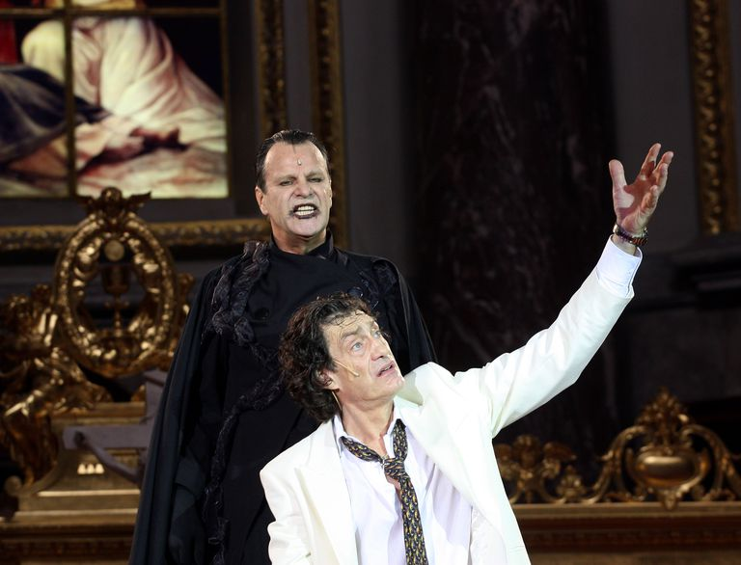

Everyman Study Guide
https://www.thoughtco.com/everyman-a-medieval-morality-play-2713422
accessed 26/02/2020 12h16.
By Wade Bradford
Wade Bradford, M.A., is an award-winning playwright and theater director. He wrote and directed seven productions for Yorba Linda Civic Light Opera's youth theater.
Updated January 14, 2020
Written in England during the 1400s, "The Summoning of Everyman" (commonly known as "Everyman") is a Christian morality play. No one knows who wrote the play. Historians note that monks and priests often wrote these types of dramas.
Morality plays were vernacular dramas, spoken in the language of the people, rather than the Latin of the Church. They were meant to be seen by the common people. Like other morality plays, "Everyman" is an allegory. The lessons being relayed are taught by allegorical characters, each one representing an abstract concept such as good deeds, material possessions, and knowledge.

Basic Plot
God decides that Everyman (a character who represents an average, everyday human) has become too obsessed with wealth and material possessions. Therefore, Everyman must be taught a lesson in piety. And who better to teach a life lesson than a character named Death?

Man Is Unkind
God’s chief complaint is that humans are ignorantly leading sinful lives; they are unaware that Jesus died for their sins. Everyman has been living for his own pleasure, forgetting about the importance of charity and the potential threat of eternal hellfire.
On God’s bidding, Death summons Everyman to take a pilgrimage to the Almighty. When Everyman realizes that the Grim Reaper has called upon him to face God and give a reckoning of his life, he tries to bribe Death to “defer this matter till another day.”
The bargaining doesn’t work. Everyman must go before God, never to return to Earth again. Death does say that the hapless hero can take along anyone or anything that may benefit him during this spiritual trial.

Friends and Family Are Fickle
After Death leaves Everyman to prepare for his day of reckoning (the moment in which God judges him), Everyman approaches a character named Fellowship, a supporting role that represents Everyman’s friends. At first, Fellowship is full of bravado. When Fellowship learns that Everyman is in trouble, he promises to stay with him until the problem is resolved. However, as soon as Everyman reveals that Death has summoned him to stand before God, Fellowship abandons him.
Kindred and Cousin, two characters that represent family relationships, make similar promises. Kindred declares, “in wealth and woe we will with you hold, for over his kin a man may be bold.” But once Kindred and Cousin realize Everyman’s destination, they back out. One of the funniest moments in the play is when Cousin refuses to go by claiming he has a cramp in his toe.
The overall message of the play’s first half is that relatives and friends (as reliable as they may seem) pale in comparison to the steadfast companionship of God.

Goods vs. Good Deeds
After getting rejected by fellow humans, Everyman turns his hopes to inanimate objects. He talks to a character named “Goods,” a role which represents Everyman’s material possessions and wealth. Everyman pleads for Goods to assist him in his hour of need, but they offer no comfort. In fact, the Goods chide Everyman, suggesting that he should have admired material objects moderately ​and that he should have given some of his goods to the poor. Not wanting to visit God (and subsequently be sent to hell), Goods deserts Everyman.​​
Finally, Everyman meets a character who will genuinely care for his plight. Good-Deeds is a character who symbolizes the acts of charity and kindness performed by Everyman. However, when the audience first meets Good-Deeds, she is laying on the ground, severely weakened by Everyman’s many sins.

Enter Knowledge and Confession
Good-Deeds introduces Everyman to her sister, Knowledge. This is another friendly character who will provide good advice to the protagonist. Knowledge serves as an important guide for Everyman, instructing him to seek out another character: Confession.
Everyman is led to Confession. Many readers expect to hear scandalous “dirt” on the main character, and expect him to beg forgiveness, or hope he will at least apologize for whatever sins he has committed. Such readers will be surprised here. Instead, Everyman asks for his vices to be wiped clean. Confession says that, with penance, Everyman’s spirit may become clean once more.
What does penance mean? In this play, it means that Everyman undergoes a severe and purifying form of physical punishment. After he suffers, Everyman is amazed to discover that Good-Deeds is now free and strong, ready to stand by his side during his moment of judgment.

The Five-Wits
After this purging of the soul, Everyman is ready to meet his maker. Good-Deeds and Knowledge tell Everyman to call upon “three persons of great might” and his Five-Wits (his senses) as counselors.
Everyman calls forth the characters Discretion, Strength, Beauty, and Five-Wits. Combined, they represent the core of his physical human experience.
Unlike the first half of the play when he begged for help from his friends and family, Everyman is now relying on himself. However, even though he receives some good advice from each entity, he realizes that they will not go the distance as he journeys closer to his meeting with God.
Like previous characters, these entities promise to stay by his side. Yet, when Everyman decides that it is time for his body to physically die (perhaps as part of his penance), Beauty, Strength, Discretion, and the Five-Wits abandon him. Beauty is the first one to leave, disgusted by the idea of lying in a grave. The others follow suit, and Everyman is left alone with Good-Deeds and Knowledge once again.

Everyman Departs
Knowledge explains that he won’t be going into the “heavenly sphere” with Everyman, but will stay with him until he departs from his physical body. This allegorically implies that the soul does not retain its Earthly knowledge.
However, Good-Deeds (as promised) will journey with Everyman. At the end of the play, Everyman commends his soul to God. After his departure, an angel arrives to announce that Everyman’s soul has been taken from his body and presented before God. A final narrator enters to explain to the audience that all should heed the lessons of Everyman: Everything in life is fleeting, with the exception of acts of kindness and charity.

Overall Theme
As one might expect from a morality play, "Everyman" has a very clear moral, one that is delivered at the beginning, middle, and end of the play. The blatantly religious message is simple: Earthly comforts are fleeting. Only good deeds and God’s grace can provide salvation.

Who Wrote 'Everyman?'
Many morality plays were a collaborative effort by clergymen and residents (often tradesmen and guild members) of an English town. Over the years, lines would be changed, added, and deleted. Therefore, "Everyman" is probably the result of multiple authors and decades of literary evolution.

Historical Context
When Everyman summons the Five-Wits, a fascinating discussion about the importance of the priesthood follows. … According to the Five-Wits, priests are more powerful than angels. This reflects the prevalent role of priests in medieval society. In most European villages, the clergy were the moral leaders. However, the character of Knowledge mentions that priests are not perfect, and some of them have committed egregious sins. The discussion concludes with a general endorsement of the Church as the surest path to salvation.

The Summoning of EVERYMAN: A Student Guide
Sandra Effinger, accessed 26/02/2020 12h22
http://homepage.mac.com/mseffie/assignments/everyman/everymansg.html,
Activity Two: The following questions ask you to recall the characters and events of the play -- what happens at the literal level.
1. Why does God send Death to summon Everyman?
2. How does Everyman react to the summons by Death?
3. The author of this play used deliberate repetition to drive home major points. In what way do Everyman's encounters with Fellowship and Kindred follow a similar pattern?
4. What happens when Everyman asks Goods to accompany him? Why does Goods think that his presence would adversely influence God's judgment of Everyman?
5. Why is Good Deeds at first unable to accompany Everyman?
6. How does Knowledge help Everyman on his journey?
7. Explain how the play supports the idea that knowledge of one's sin is necessary before one can truly repent.
8. How does the order in which Beauty, Strength, Discretion, and Five Wits abandon Everyman parallel the process of aging?
9. Who follows Everyman into the grave?
10. What does the weakness of Good Deeds reveal about the way Everyman has led his life?
Activity Four: Consider how you might use costume to identify each of the characters. List each character, describe the costume you have chosen, and explain how each character's costume and behavior might appropriately personify that abstract idea:
God, Everyman, Death, Fellowship, Kindred, Cousin, Goods, Good Deeds, Knowledge, Confession, Beauty, Strengh, Discretion, Five Wits, Messenger, Doctor

